**Shell Scripting Fundamentals**

* **Review Shell Syntax:**
  + Study variable assignment and usage (e.g., C=$A+$B, D=$(($A+$B))).
  + Practice using if, elif, and else conditional statements.
  + Understand how to use for and while loops.

|  |
| --- |
| * #!/bin/bash * let i=0 * echo "while ((\$i<10));do" * while (($i<10));do * echo "$i" * ((i++)) * done * echo "for (( a=0; a<10; a++ m));do" * for (( a=0; a<10; a++ ));do * echo "$a" * done * echo "for a in {1..10};do" * for a in {1..10};do * echo $a * done * #!/bin/bash * while IFS= read -r line; do * echo "$line" * done < file1.txt |

* + Pay attention to command-line arguments and how to access them (e.g., $1, $#, $@).
  + Switch

|  |
| --- |
| * case "$1" in * "1") * echo "one";; * "2") * echo "two";; * *) * echo "Da hyi znaet";; * esac |

|  |
| --- |
| * #!/bin/bash * if [ -f names.txt ]; then * echo "regular file" # Checks if 'names.txt' is a regular file. * fi * if [ -d ./ ]; then * echo "it's directory" # Checks if the current directory './' is a directory. * fi * if [ -e names.txt ]; then * echo "File exists" # Checks if 'names.txt' exists (file or directory). * fi * if [ -r names.txt ]; then * echo "u can read" # Checks if 'names.txt' is readable. * fi * if [ -w names.txt ]; then * echo "u can write" # Checks if 'names.txt' is writable. * fi * if [ -e names.txt ]; then * echo "u can execute" # This condition should be -x to check execute permission, not -e. -e just checks existence * fi * if [ logs.txt -ot names.txt ]; then * echo "logs" # Checks if 'logs.txt' is older than 'names.txt'. * else * echo names # If logs.txt is not older than names.txt, it prints "names", not the content of names.txt * fi * if [ $# -ge 1 ]; then * echo "I am happy" # Checks if the number of command-line arguments ($#) is greater than or equal to 1. * echo $1 # Prints the first command-line argument ($1). * elif [ -n "$2" ] && [ -z "$2" ]; then * echo "I am NOT happy" # This condition will *never* be true. A string cannot be both non-empty (-n) AND empty (-z) at the same time. * fi * if [ -z names.txt ]; then * echo "Nothing inside" # This checks if the *string* "names.txt" is empty, not if the file is empty. It will always be false. * fi * file=$(cat name.txt 2>> error.txt) # Capture standard output of cat name.txt, redirect standard error to error.txt * if [ -z "$file" -a 2 -ge 1 ]; then * echo "Nothing inside" # Checks if $file is empty AND if 2 is greater than or equal to 1 (which is always true). * else * echo "Where's the fuck did u find it?" # This part will almost always execute, unless cat name.txt produces no output AND an error * fi |

|  |  |
| --- | --- |
| * 10 * 1+1 * 2 * 3 * hi, there * 5 * 10 * 76 syntax.sh * 76 * names.txt * You gave me 1 this much of variables * h * e * l * l * o * w * hello * 0 1 2 3 4 5 6 7 8 9 10 11 12 13 14 15 16 17 18 19 20 21 22 23 24 25 26 27 28 29 30 31 32 33 34 35 36 37 38 39 40 41 42 43 44 45 46 47 48 49 50 51 52 53 54 55 56 57 58 59 60 61 62 63 | * 64 65 66 67 68 69 70 71 72 73 74 75 76 77 78 79 80 81 82 83 84 85 86 87 88 89 90 91 92 93 94 95 96 97 98 99 * John Smith * Alice Wonderland * Bob The Builder * Carol Danvers * Peter Parker * Bruce Wayne * John * Smith * Alice * Wonderland * Bob * The * Builder * Carol * Danvers * Peter * Parker * Bruce * Wayne |

* **Mastering Conditional Expressions:**
  + Familiarize yourself with the syntax for file tests (e.g., -f, -z).
  + Practice using string comparisons (e.g., =, !=) and integer comparisons (e.g., -gt, -lt, -eq, -ne).
  + Understand how to combine conditions using -a (and) and -o (or).

|  |
| --- |
| * #!/bin/bash * if [ -f names.txt ]; then # If names.txt is a regular file * echo "regular file" * fi * if [ -d ./ ]; then # If current dir is a directory * echo "it's directory" * fi * if [ -e names.txt ]; then # If names.txt exists * echo "File exists" * fi * if [ -r names.txt ]; then # If names.txt is readable * echo "u can read" * fi * if [ -w names.txt ]; then # If names.txt is writable * echo "u can write" * fi * if [ -x names.txt ]; then # If names.txt is executable (was -e, should be -x) [cite: 6] * echo "u can execute" * fi * if [ logs.txt -ot names.txt ]; then # If logs.txt is older than names.txt * echo "logs" * else * echo names * fi * if [ $# -ge 1 ]; then # If at least 1 argument * echo "I am happy" * echo $1 * elif [ -n "$2" ] && [ -z "$2" ]; then # This is always false * echo " I am NOT happy" * fi * if [ -z names.txt ]; then # If "names.txt" is empty (wrong check) * echo "Nothing inside" * fi * file=$(cat name.txt 2>> error.txt) # Get file content, redirect errors * if [ -z "$file" -a 2 -ge 1 ]; then # If file is empty and 2 >= 1 * echo "Nothing inside" * else * echo "Where's the fuck did u find it?" * fi |
| regular file  it's directory  File exists  u can read  u can write  names  I am happy  hi  Nothing inside |

**Commands and Utilities**

* **File Manipulation:**
  + Practice using head, tail, sort, uniq, cut, find, mv, rm.
  + Understand how to redirect input and output (e.g., <, >, >>, 2>>).
  + Review file permissions and how to change them with chmod.
* **Text Processing:**
  + Practice using grep and egrep for pattern matching.

|  |
| --- |
| * egrep "cat|dog" file.txt # Find lines containing either "cat" or "dog" * grep "cat\|dog" file.txt # Equivalent grep command (requires escaping) * egrep "(hello)+" file.txt # Find lines with one or more occurrences of "hello" * grep "\(hello\)\+" file.txt # Equivalent grep command (requires escaping) * egrep "colou?r" file.txt # Find lines with "color" or "colour" * grep "colou\?r" file.txt # Equivalent grep command (requires escaping) |

* Understand how to use wc to count lines, words, and characters.
* **General Commands:**
  + Memorize the basic functions of commands like ls, mkdir, touch, cat, cd, nano, man, clear, nl, file, tr, let, rmdir, and cp.

**Specific Tasks**

* **Write scripts to:**
  + Process command-line arguments.
  + Read files line by line using while loops.
  + Find files based on name or other criteria.
  + Manipulate text within files (e.g., extract specific lines, sort, remove duplicates).
  + Perform calculations using let.
  + Rename or move files.
  + Use conditional statements to make decisions.
* **Given a code snippet, explain what it does.**
* **Identify errors in a given script.**
* **Write one-line commands to perform specific tasks.**

**Text Example 1: data.txt**

Plaintext

apple,10,red,sweet

banana,5,yellow,sweet

orange,12,orange,tart

grape,25,purple,tart

apple,8,green,sour

kiwi,15,brown,sour

banana,7,yellow,sweet

**Text Example 2: logs.txt**

Plaintext

2024-07-20 10:00:01 - User logged in: user123

2024-07-20 10:05:22 - File accessed: /home/user123/document.txt

2024-07-20 10:12:48 - Error: Connection timeout

2024-07-20 11:01:15 - User logged out: user123

2024-07-21 09:22:30 - User logged in: guest

2024-07-21 09:28:45 - File accessed: /var/log/system.log

2024-07-21 10:15:00 - Warning: Disk space low

2024-07-21 11:59:59 - User logged out: guest

**Text Example 3: names.txt**

Plaintext

John Smith

Alice Wonderland

Bob The Builder

Carol Danvers

Peter Parker

Bruce Wayne

**Text Example 4: numbers.txt**

Plaintext

1

10

100

1000

10000

2

20

200

2000

**Example Exercises Using These Texts**

Here are some exercises that utilize these text examples, combining the commands and concepts from your files:

**Using data.txt**

* **Extract fruit names:** Write a command to extract only the fruit names from data.txt.
* **Filter by color:** Write a script to ask the user for a color and then print all lines from data.txt that match that color.
* **Calculate total quantity:** Write a script to calculate the total quantity of all fruits.
* **Find the sweetest fruit:** Write a script to determine which fruit is listed as "sweet" and has the highest quantity. (Similar to the "biggest line" example in codeInShell.txt but applied to different criteria)
* **Count unique fruits:** Write a command to list the unique fruit names.

|  |
| --- |
| * #!/bin/bash * echo "In your basket you have these fruits: " * basket=$(cut -d ',' -f1 text.txt) * for i in $basket;do * echo $i * done * echo "Gimme color to give you your fruit match: " * color="" * read color * while IFS=',' read -r name num ocolor type;do * if [ $ocolor = $color ];then * echo "$name, $num, $ocolor, $type" * fi * done < text.txt * total=$(wc -l < text.txt) * echo "Total quantity of fruits in your basket: $total fruits" * sweet=$(grep "sweet" text.txt | cut -d ',' -f2) * rm quantity.txt * for i in $sweet;do * echo $i >> quantity.txt * done * max=$(sort quantity.txt | head -1) * max=$(grep $max text.txt) * echo "$max" * #fruit_list=$(cut -d ',' -f1 text.txt | sort | uniq) * #count=$(echo $fruit_list | wc -w) * #echo "There are $count unique fruits: $fruit_list" * count=0 * names="" * fruit=$(cut -d ',' -f1 text.txt) * rm names.t * for i in $fruit; do * echo "$i" >> names.t * done * exist=0 * while read -r name; do * for j in $names; do * if [ "$j" = "$name" ]; then * exist=1 * fi * done * if [ "$exist" -eq 0 ]; then * names="$names $name" * ((count++)) * fi * exist=0 * done < names.t * echo "There're $count of fruits: $names" |
| * In your basket you have these fruits: * apple * banana * orange * grape * apple * kiwi * banana * Gimme color to give you your fruit match: * yellow * banana, 5, yellow, sweet * banana, 7, yellow, sweet * Total quantity of fruits in your basket: 7 fruits * apple,10,red,sweet * There're 5 of fruits: apple banana orange grape kiwi |

**Using logs.txt**

1. **Find login/logout times for a user:** Write a script that takes a username as input and prints the login and logout times for that user.
2. **Count error/warning messages:** Write a command to count the number of lines containing "Error" or "Warning".
3. **Extract file paths:** Write a command to extract the file paths accessed (e.g., /home/user123/document.txt).
4. **Find the latest event:** Write a command to display the last line of the log file.
5. **Analyze user activity:** Write a script to determine how many unique users are in the log file.

|  |
| --- |
| * #!/bin/bash * grep "logged" logs.txt | while read -r lines;do * echo $lines | grep "in" | while read -r line;do * echo "$line ---1" * done * echo $lines | grep "out" | while read -r line;do * echo "$line ---2" * done * done * count=$(grep "logged in" logs.txt | wc -l) * echo "Before starting, there --$count-- of user in the system" * logedin=$(grep "logged in" logs.txt | grep $1 | cut -d ' ' -f2) * logedout=$(grep "logged out" logs.txt | grep $1 | cut -d ' ' -f2) * echo "User log time: " * echo " Logged in: $logedin" * echo " Logged out: $logedout" * count=0 * while read -r line;do * for i in $line;do * if [ $i = $1 ];then * echo "$line" >> "$1.txt" * ((count++)) * break * elif [ $count -eq 1 ];then * echo "$line" >> "$1.txt" * fi * done * done < logs.txt * #lines="" * rm "n$1.txt" * cat "$1.txt" | uniq | while read -r line;do * echo $line >> n$1.txt * #lines="$lines\n$line" * done * rm "$1.txt" * count=$(egrep 'Error|Warning' n$1.txt | wc -l) * echo "$1 user got $count error/warning messages" * path=$(cut -d ' ' -f6 n$1.txt | egrep '/*/') * echo "$1 user accessed this pathes: $path" * echo "$1 user had done before logging out: $(tail -2 n$1.txt | head -1 | cut -d ":" -f4)" |
| * 2024-07-20 10:00:01 - User logged in: user123 ---1 * 2024-07-20 11:01:15 - User logged out: user123 ---2 * 2024-07-21 09:22:30 - User logged in: guest ---1 * 2024-07-21 11:59:59 - User logged out: guest ---2 * Before starting, there --2-- of user in the system * User log time: * Logged in: 10:00:01 * Logged out: 11:01:15 * user123 user got 1 error/warning messages * user123 user accessed this pathes: /home/user123/document.txt * user123 user had done before logging out: Connection timeout |

**Using names.txt**

1. **Extract first names:** Write a command to extract the first names.
2. **Reverse the names:** Write a script to print the names in the format "Smith, John".
3. **Count names with a specific letter:** Write a script to count how many names contain the letter "a" (case-insensitive).
4. **Print names in uppercase:** Write a command to print all names in uppercase.
5. **Sort names alphabetically:** Write a command to sort the names alphabetically.

|  |
| --- |
| * #!/bin/bash * first_name=$(cut -d ' ' -f1 names.txt) * if [ -e surnames.txt ];then * rm surnames.txt * fi * for a in $first_name;do * echo "$(grep $a names.txt | cut -d ' ' -f2), $a" >> surnames.txt * echo "$(echo $a | tr [:lower:] [:upper:])" * done * let count=$(cut -d ' ' -f1 names.txt | egrep 'a|A' | wc -w)+$(cut -d ' ' -f2 names.txt | egrep 'a|A' | wc -w) * echo "There are --$count-- of names that contain lettar \"a\"" * #echo "$(cut -d ' ' -f1 names.txt | cut -c1 | tr [:lower:] [:upper:])$(cut -d ' ' -f1 names.txt | cut -c2-) " * cut -d ',' -f2 surnames.txt | sort | while read -r line;do * echo "$(grep $line surnames.txt)" * done |
| * JOHN * ALICE * BOB * CAROL * PETER * BRUCE * There are --6-- of names that contain lettar "a" * Wonderland, Alice * The, Bob * Wayne, Bruce * Danvers, Carol * Smith, John * Parker, Peter |

**Using numbers.txt**

1. **Calculate the sum:** Write a script to calculate the sum of all numbers.
2. **Find numbers greater than a value:** Write a script that takes a number as input and prints all numbers from the file greater than that number.
3. **Find the average:** Write a script to calculate the average of the numbers.
4. **Find the largest and smallest number:** Write a script to determine the largest and smallest numbers.
5. **Filter even numbers:** Write a script to print only the even numbers from the file.

|  |
| --- |
| * #!/bin/bash * let total=0 * read=$(cat numbers.txt) * for i in $read;do * let total=$total+$i * if [ $i -gt $1 ];then * echo $i * fi * #if (( $i%2 == 0 ));then * if [ $(($i%2)) -eq 0 ];then * echo "Even: $i" * fi * done * echo "The sum of numbers.txt is: $total" * echo "The avarage of numbers.txt is: $(($total/$(wc -l < numbers.txt)))" |
| * Even: 10 * 100 * Even: 100 * 1000 * Even: 1000 * 10000 * Even: 10000 * Even: 2 * 20 * Even: 20 * 200 * Even: 200 * 2000 * Even: 2000 * The sum of numbers.txt is: 13333 * The avarage of numbers.txt is: 1481 |

**1. ls (List directory contents)**

* **Basic usage:**

Bash

ls

This will list the files and directories in your current working directory.

* **Long listing:**

Bash

ls -l

This provides more detailed information, including permissions, owner, size, and modification date. (As potentially shown in the image prompt).

**2. mkdir (Create directories)**

* **Basic usage:**

Bash

mkdir new_directory

This creates a directory named new_directory in your current location.

**3. touch (Create empty files or update timestamps)**

* **Create a file:**

Bash

touch new_file.txt

This creates an empty file named new_file.txt.

**4. cat (Concatenate and display files)**

* **Display a file's content:**

Bash

cat file.txt

This will print the contents of file.txt to your terminal.

**5. cd (Change directory)**

* **Go to a specific directory:**

Bash

cd Documents

This changes your current directory to the Documents directory.

* **Go back to the previous directory:**

Bash

cd -

* **Go to your home directory:**

Bash

cd ~

or just:

Bash

cd

**6. man (Display manual pages)**

* **Get help for a command:**

Bash

man ls

This will display the manual page for the ls command, explaining its options and usage.

**7. chmod (Change file permissions)**

* **Grant read permission to the user for myfile.txt (from codeInShell.txt):**

Bash

chmod u+r myfile.txt

**8. wc (Word count)**

* **Count lines in a file (from codeInShell.txt):**

Bash

n=$(wc -l < file.txt)

echo "$n"

This counts the number of lines in file.txt and stores the result in the variable n.

* **Count characters in a variable (from codeInShell.txt):**

Bash

lines="some text here"

chars=$(echo "$lines" | wc -m)

echo "$chars"

**9. head (Output the first part of files)**

* **Display the first 4 lines of file.txt (from codeInShell.txt):**

Bash

head -n 4 file.txt

or

Bash

T=$(head -4 file.txt)

echo "$T"

**10. tail (Output the last part of files)**

* **Display the last 3 lines of the output of head -n 5 file.txt (from codeInShell.txt):**

Bash

head -n 5 file.txt | tail -n 3

**11. sort (Sort lines of text files)**

* **Sort the contents of file.txt and output to result.txt (from codeInShell.txt):**

Bash

sort "file.txt" > result.txt

**12. uniq (Remove duplicate lines)**

* **Sort file.txt and remove duplicate lines, saving to result.txt (from codeInShell.txt):**

Bash

sort "file.txt" | uniq > result.txt

**13. cut (Remove sections from each line of files)**

* **Example (not directly in your snippets, but common):**

Bash

cut -d':' -f1 /etc/passwd

This would cut the /etc/passwd file, using : as a delimiter, and display only the first field (usernames).

**14. nl (Number lines of files)**

* **Basic usage:**

Bash

nl file.txt

This will number the lines of file.txt.

**15. file (Determine file type)**

* **Check the type of myfile.txt:**

Bash

file myfile.txt

This will tell you if it's a regular file, directory, etc.

**16. find (Find files and directories)**

* **Find files named like $1 in your home directory (from codeInShell.txt):**

Bash

find ~ -name "$1"

find ./ -name "names*" -exec cat {} \;

If you ran a script with ./my_script report.txt, this would find files named report.txt in your home directory.

* **Find regular files named t*.txt in the current directory (from codeInShell.txt):**

Bash

find ./ -type f -name 't*.txt'

**17. tr (Translate or delete characters)**

* **Example (not directly in your snippets, but common):**

Bash

echo "lowercase" | tr '[:lower:]' '[:upper:]'

This would translate all lowercase characters to uppercase, outputting "LOWERCASE".

**18. let (Perform arithmetic operations)**

* **Add two variables (from codeInShell.txt):**

Bash

A=5

B=10

let C=$A+$B

echo "$C" # Output: 15

D=$(($A+$B)) # Another way to do arithmetic expansion

echo "$D" # Output: 15

* **Increment a variable (from codeInShell.txt):**

Bash

i=0

while [ $i -lt 5 ]; do

echo "$i"

((i+=1)) # Arithmetic increment

done

or

Bash

i=0

while [ $i -lt 5 ]; do

echo "$i"

let i=i+1 # Using let for increment

done

* **Integer division (from codeInShell.txt):**

Bash

result=100

i=0

while [ $i -lt 2 ]; do

((i+=1))

let result=$result/2

echo "$result" # Output: 50, 25

done

**19. rm (Remove files or directories)**

* **Remove a file (from codeInShell.txt):**

Bash

f="temp.txt"

# ... some operations ...

rm "$f"

**Use rm with caution!** It permanently deletes files.

**20. rmdir (Remove empty directories)**

* **Remove an empty directory:**

Bash

rmdir empty_directory

This will only work if empty_directory is indeed empty.

**21. cp (Copy files and directories)**

* **Copy a file:**

Bash

cp source.txt destination.txt

* **Copy a directory recursively (to include its contents):**

Bash

cp -r source_directory destination_directory

**22. for (Looping construct)**

* **Loop through words in a string (from codeInShell.txt):**

Bash

for l in $(cat file.txt); do

echo "Word: $l"

done

* **Loop through command-line arguments (from codeInShell.txt):**

Bash

for arg in "$@"; do

echo "Argument: $arg"

done

* **Loop through files matching a pattern (from codeInShell.txt):**

Bash

for i in *.txt; do

egrep '^a.{9}' "$i"

done

* **Loop through a sequence of numbers (from codeInShell.txt):**

Bash

lines="some\ntext\nhere"

for i in $(seq 0 $(($(echo "$lines" | wc -m) - 1))); do

char="${lines:i:1}"

echo "Position $i: $char"

done

**23. while (Looping construct)**

* **Read a file line by line (from codeInShell.txt):**

Bash

while read -r line; do

echo "Line: $line"

done < input.txt

* **Loop based on a condition (from codeInShell.txt):**

Bash

i=0

while [ $i -lt 5 ]; do

echo "$i"

((i+=1))

done

* **Process lines from a command output (from codeInShell.txt):**

Bash

lines=$(egrep "^a" "file.txt")

echo "$lines" | while read -r line; do

echo "Line starting with 'a': $line"

done

**24. grep, egrep (Find patterns in text)**

* **Find lines starting with "a" in file.txt (from codeInShell.txt):**

Bash

lines=$(egrep "^a" "file.txt")

echo "$lines"

* **Find lines starting with "c" in $1 (from codeInShell.txt):**

Bash

lines=$(egrep "^c" "$1")

* **Find lines in *.txt files starting with 'a' followed by exactly 9 characters (from codeInShell.txt):**

Bash

for i in *.txt; do

egrep '^a.{9}' "$i"

done

|  |
| --- |
| #!/bin/bash  # 1. Create "SOP" directory in your home directory.  mkdir ~/SOP  # 2. Go to "SOP" directory and create "Class1" directory.  cd ~/SOP  mkdir Class1  # 3. Go back to your home directory and directly, with one command, go to the "Class1" directory.  cd ~/SOP/Class1  # 4. Create two files, "File1.txt" and "File2.txt".  touch File1.txt File2.txt  # 5. Change the permissions of the "File2.txt" file to read and execute.  chmod a+rx File2.txt  # 6. Check if permissions have been changed.  ls -l File2.txt  # 7. Go to your home directory and list all directories together with their content.  cd ~  ls -R  # 8. Check the manual of the nano and cat commands. Then write to file "File1.txt" text "Hello Linux", then display it.  man nano  man cat  echo "Hello Linux" > File1.txt  cat File1.txt  # 9. Add at least 15 lines of text to file "File1.txt"  for i in {1..15}; do echo "This is line number $i" >> File1.txt; done  # 10. Display sorted content of the file "File1.txt".  sort File1.txt  # 11. Display first 4 lines of the file "File1.txt"  head -n 4 File1.txt  # 12. Display last 3 lines of the file "File1.txt"  tail -n 3 File1.txt  # 13. Count number of words in the file "File1.txt"  wc -w File1.txt  # 14. Count number of characters in the file "File1.txt"  wc -m File1.txt |

|  |
| --- |
| #!/bin/bash  # 1. Create directory "Class2". Create a file "text.txt" with at least 30 lines (some duplicates).  mkdir Class2  cd Class2  cd ..  # 2. Create file "file1.txt" with the first 10 lines of "text.txt".  head -n 10 Class2/text.txt > file1.txt  # 3. Write to the end of "file1.txt" the last 10 lines of "text10.txt".  if [ -f "text10.txt" ]; then    tail -n 10 text10.txt >> file1.txt  else    echo "Warning: text10.txt not found, skipping step 3."  fi  # 4. Print content of "file1.txt" on the console with echo and streams.  while IFS= read -r line; do    echo "$line"  done < file1.txt  # 6. Print content of "text.txt" without duplicated lines.  uniq Class2/text.txt  # 7. Sort lines from "text.txt" and print it on the console with pipe and cat.  sort Class2/text.txt | cat  # 8. Create and run bash script to display "Hello bash".  echo 'echo "Hello bash"' > hello.sh  chmod +x hello.sh  ./hello.sh  # 9. Create and run bash script to display the sum of two digits given as arguments.  A=2  B=3  let C=$A+$B  D=$(($A+$B))  echo Sum is $C or $D  T=$(head -4 file.txt)  echo "$T"  # 10. Create and run bash script to display all arguments and the number of arguments.  echo "Hello bash"  Sum=$(($1+$2))  echo "The sum is: $Sum"  echo "The numer of all args: $#"  echo "All args: $@" |

|  |
| --- |
| #!/bin/bash  # 1. Sort, delete duplicates, and save to result1.txt  sort "$1" | uniq > result.txt  # 2. Search for a file given as an argument starting from the home directory  find ~ -name "$1"  # 3. Find lines starting with "a" in the first file and append to the second file  grep "^a" "$1" >> "$2"  # 4. Count cars left after a number of days  result=$1  i=0  while [ $i -lt $2 ]  do   ((i+=1))   let result=$result/2  done  echo $result  # 5. Display lines starting with "a" and containing at least 10 characters from every text file  for i in *.txt  do         egrep '^a.{9}' $i  done  # 6. Cut 3rd, 4th, and 5th lines, sort, unique, and prefix with line number  for i in *.txt  do   lines=$(head -n 5 $i | tail -n 3 | sort | uniq)   n=$(wc -l < $1)   echo "$lines" | while read -r line   do    echo "$n $line" >> $1                  ((n+=1))   done  done |

|  |
| --- |
| #!/bin/bash  # Script to display animal sounds  # Supported animals: Cat, Dog, Cow  for animal in "$@"; do  case "$animal" in  Cat)  echo "$animal goes mew mew"  ;;  Dog)  echo "$animal goes woof woof"  ;;  Cow)  echo "$animal goes moo moo"  ;;  *)  echo "Unknown animal: $animal"  echo "Supported animals: Cat, Dog, Cow"  ;;  esac  done  # Script to delete text files with over 10 lines  for f in *.txt;do  c=$(wc -l < $f)  if [ $c -gt 10 ]  then  rm $f  fi  done  # Script to move text files starting with 't' to a target directory  files=$(find ./ -type f -name 't*.txt')  for f in $files  do  mv $f $1 2>> errors.txt  done  # Script to find the longest line starting with 'c' and save it  lines=$(egrep "^c" $1)  biggest=0  while read -r l;do  chars=$(echo $l | wc -m)  if [ $chars -ge $biggest ]  then  biggest=$chars  line=$l  fi  done <<< "$lines"  echo $line  echo $line >> $2  # Script to modify .log files in the home directory  for f in ~/*.log;do  lines=$(wc -l < $f)  if [ $lines -gt 10 ]  then  echo "$(tail $f)" > $f  echo "file $f was reduced"  else  echo "Too few lines in the file $f to reduce"  fi  done  # Script to display the newest file name in the current directory  i=0  for f in $(ls)  do  if [ $i -eq 0 ]  then  last=$f  ((i+=1))  elif [ $f -nt $last ]  then  last=$f  fi  done  echo $last  # Script to process text files in the home directory  sum=0  for file in ~/*.txt  do  if [ ! -r  $file ]  then  chmod u+r $file  fi  num=$(head -8 $file | tail -4 | sort | uniq | wc -m)  ((sum+=$num))  done  echo $sum  # Script to check a file and process characters in lines 2, 3, and 4  if [ -f $1 ]  then  lines=$(head -4 $1 | tail -3)  for i in $(seq 0 $(($(echo "$lines" | wc -m) - 1)))  do  char="${lines:i:1}"  echo "Position $i: $char"  done  else  echo "It is not a regular file"  exit 1  fi |

# Generate numbers from 2 to 10, incrementing by 2

seq 2 2 10

for i in {1..5};do echo $i;done

Write a script which takes a regular file path as the first argument. If you have a reading permission print lines in range <5,8> from this file to the command line. If you don't have this permission, print the proper information to the command line and end the execution of the script.

|  |
| --- |
| #!/bin/bash  if [ $# -ne 1 ];then  echo "Get lost"  exit 1  fi  path=$1  if [ -r $path ]; then  head -8 $path | tail -4  else  echo "U are loser and don't have ringhts. Are u a boy?"  fi |

Write a script which takes a directory path as the first argument. Iterate over all files in this directory (Including hidden files) and count the sum of all lines in the regular files. Print the counted value to the command line.echo

|  |
| --- |
| #!/bin/bash  if [ $# -ne 1 -o ! -d $1 ];then  echo "Bad boy"  exit -1  fi  count=0  for i in $(ls -a $1);do  if [ -f $i ];then  #while read -r line;do  # ((count++))  #done < $i  let count=$count+$(wc -l < $i)  fi  done  echo "The sum is: $count" |

Write a script which takes the following arguments in order: fish species, size of the fish, year when it was caught. Script should save this value. Additionally, the script should accept a run with the first argument equal to "-c", after which the following value should be a year. (example: "./script.sh -c 2025") In this case the script should count the quantity and average size for each of the species in the given year. The counted values should be printed on the command line followed by the name of species.

|  |
| --- |
| #!/bin/bash  if [ $# -eq 3 ];then  echo "$1 $2 $3" >> fish.txt  fi  if [ $1 = "-c" -a $# -eq 2 ];then  let count=0  a=$(cut -d ' ' -f3 fish.txt)  while read -r line;do  if [ $line -eq $2 ];then  let count=$count+1  fi  done <<<"$a"  echo "In $2 year was found: $count"  fi |

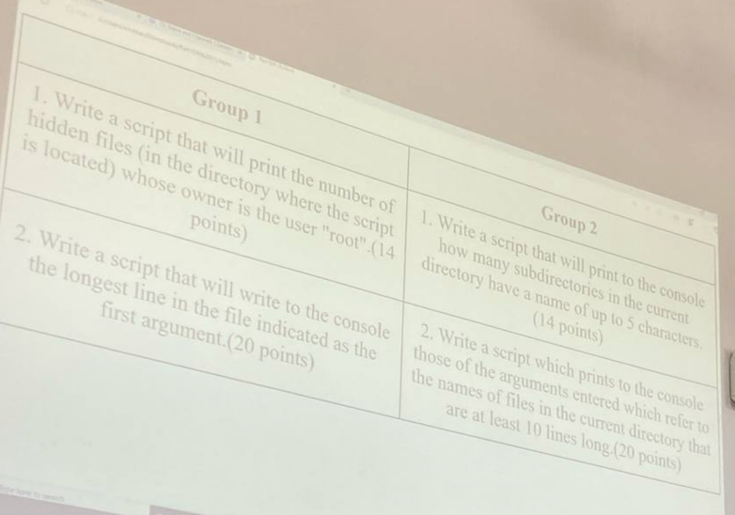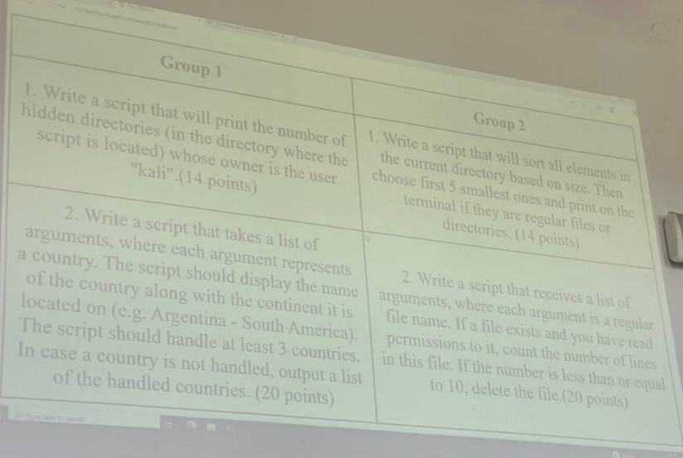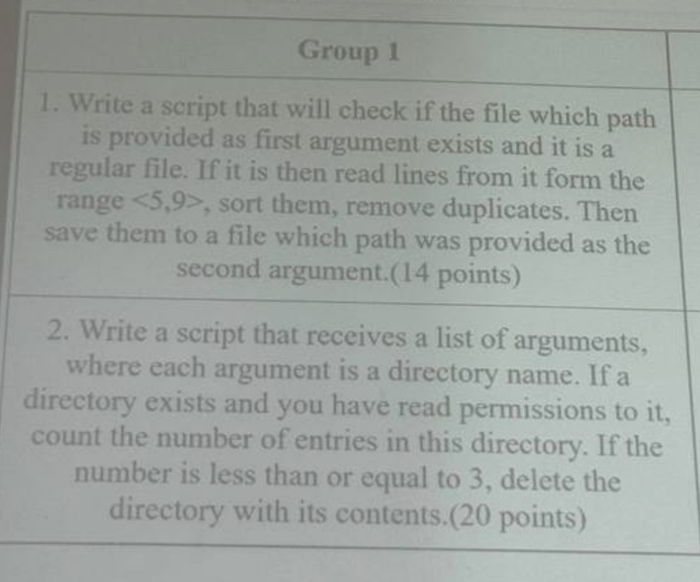 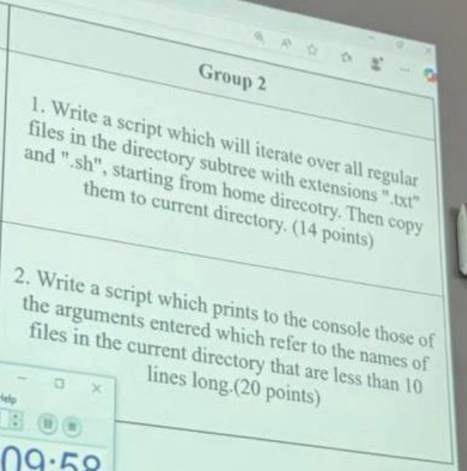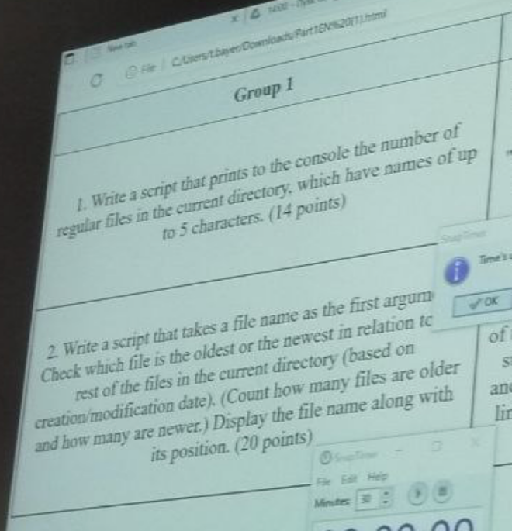 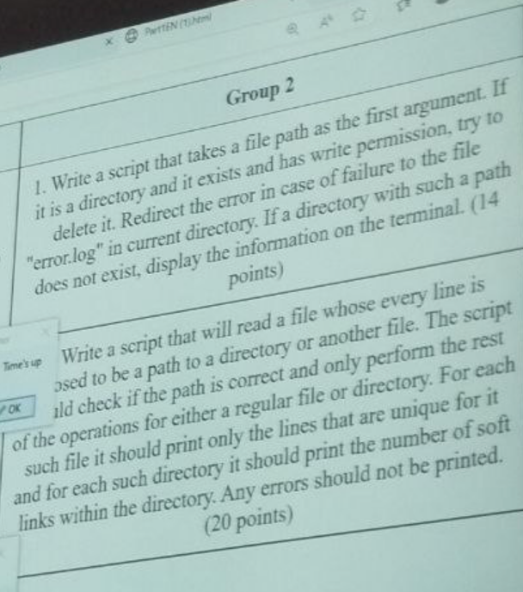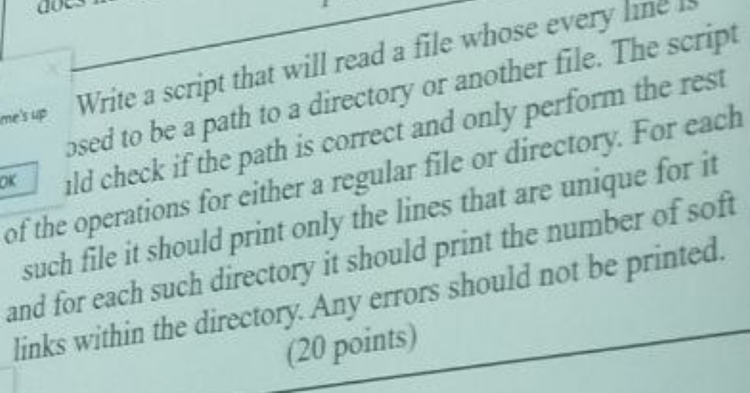

|  |
| --- |
| #!/bin/bash  for i in $@;do  count=$(sort $i | uniq | wc -l)  if [ $count -ge 17 ];then  echo $i  fi  done  #!/bin/bash  count=1  path=""  for a in $(ls -SR);do  for b in $a;do  if [ $count -eq 0 ];then  if [ -r "$path/$b" ];then  echo "$path/$b"  ((count++))  fi  elif [ -z $(echo $b | cut -d '.' -f1) ];then  path=$(echo $b | cut -d ':' -f1)  if [ -r $path ];then  count=0  fi  fi  done  done  #!/bin/bash  for i in $(ls -aS | tail -5);do  if [ -f $i ];then  echo "File: $i"  elif [ -d $1 ];then  echo "Dir: $i"  fi  done  #!/bin/bash  if [ $# -eq 0 ];then  echo "Bad boy"  exit 1  fi  linem=""  max=0  while read -r line;do  temp=$(echo $line | wc -m)  if [ $temp -gt $max ];then  max=$temp  linem=$line  fi  done < $1  echo "The longest line($max): $linem"  #!/bin/bash  for i in $@;do  count=1  if [ -f $i ];then  while read -r line;do  for w in $line;do  if [ $w = "main()" -a $count -le 10 ];then  echo "$count: $i"  fi  done  ((count++))  done < $i  else  echo "$i not a reg file"  fi  done  #!/bin/bash  for i in $(ls -aS | tail -5);do  if [ -f $i ];then  echo "File: $i"  elif [ -d $1 ];then  echo "Dir: $i"  fi  done  #!/bin/bash  if [ $# -eq 0 ];then  echo "Bad boy"  exit 1  fi  linem=""  max=0  while read -r line;do  temp=$(echo $line | wc -m)  if [ $temp -gt $max ];then  max=$temp  linem=$line  fi  done < $1  echo "The longest line($max): $linem"  #!/bin/bash  count=0  while read -r line;do  if [ $(echo "$line" | wc -m) -eq 8 ];then  echo "$line -> $(echo "$line" | wc -m)"  ((count++))  fi  done <<< $(sort $1 | uniq) #string  echo $count  #!/bin/bash  if [ $# -ne 2 ];then  echo "Bad boy"  exit 1  fi  if [ -e $1 -a -f $1 ];then  echo "$(head -9 $1 | tail -5 | sort | uniq)" > $2  fi  cat $2  #!/bin/bash  if [ $# -eq 0 ];then  echo "Bad boy"  exit 1  fi  for i in $@;do  if [ -e $i -a -r $i ];then  num=$(ls -a $i | wc -w)  if [ $num -le 3 ]; then  rm -r $i  echo "Removed $i"  fi  fi  done  #!/bin/bash  let count=0  while read -r line;do  if [ -e $line ];then  if [ -f $line -a ! -d $line ];then  echo "File: "  sort $line | uniq  elif [ -d $line ];then  full=$(ls -a $line)  for i in $full;do  if [ -h "$line/$i" ];then  echo "Soft: $i"  else  echo "Something else: $i"  fi  done  fi  fi  done < paths.txt  #!/bin/bash  find ./ -name "*.txt" -type f -exec cp {} ./copy \;  find ./ -name "*.sh" -type f -exec cp {} ./copy \;  #!/bin/bash  if [ $# -eq 0 ];then  echo "Bad boy"  exit 1  fi  for i in $(cat $1);do  case "$i" in  "A")  echo "B";;  "B")  echo "A";;  *)  echo "A, B";;  esac  done  #!/bin/bash  for i in "$@";do  if [ -e "$i" -a -r "$i" ];then  num=$(wc -l < $i)  if [ "$num" -le 10 ];then  rm "$i"  else  echo "More or less then 10 line: $i - $num"  fi  fi  done  #!/bin/bash  if [ $# -lt 1 ];then  echo "Bad boy"  exit -1  fi  older=0  newer=0  for i in $(ls -a ./);do  if [ $1 -nt $i ];then  echo "Newer then: $i"  ((newer++))  elif [ $1 -ot $i ];then  echo "Older then: $i"  ((older++))  fi  done  echo "File $1 is newer then $newer files and older than $older files"  #/bin/bash  taking=$(find ./ -user "$1" | cut -d '/' -f2)  nost=""  for i in $taking;do  if [ $(echo $i | cut -d '.' -f1 | wc -w) -eq 0 ];then  nost="$nost $i"  fi  done  nost=$(echo $nost | wc -w)  echo "Here was $nost files that belong to $1"  #!/bin/bash  if [ ! $# -gt 0 ]; then  echo "Bad boy"  exit -1  fi  if [ -d $1 -a -e $1 -a -w $1 ];then  rmdir $1 2>> error.log  else  echo "The $1 does not exist"  fi  #!/bin/bash  for i in $(ls -a ./);do  if [ -f $i -a $(echo $i | cut -d '.' -f1 | wc -m) -lt 6 ];then  echo $i  fi  done  #!/bin/bash  if [ $# -ne 2 ];then  echo "Bad boy"  exit 1  fi  if [ -e $1 -a -f $1 ];then  echo "$(head -9 $1 | tail -5 | sort | uniq)" > $2  fi  cat $2  #!/bin/bash  if [ $# -eq 0 ];then  echo "Bad boy"  exit 1  fi  for i in $@;do  if [ -e $i -a -r $i ];then  num=$(ls -a $i | wc -w)  if [ $num -le 3 ]; then  rm -r $i  echo "Removed $i"  fi  fi  done  #!/bin/bash  let count=0  while read -r line;do  if [ -e $line ];then  if [ -f $line -a ! -d $line ];then  echo "File: "  sort $line | uniq  elif [ -d $line ];then  full=$(ls -a $line)  for i in $full;do  if [ -h "$line/$i" ];then  echo "Soft: $i"  else  echo "Something else: $i"  fi  done  fi  fi  done < paths.txt  #!/bin/bash  find ./ -name "*.txt" -type f -exec cp {} ./copy \;  find ./ -name "*.sh" -type f -exec cp {} ./copy \;  #!/bin/bash  for a in $@;do  for b in $(ls -a);do  if [ $a = $b ];then  echo "Same: $a"  if [ $(wc -l < $a 2> error.log) -lt 10 ];then  echo " all good"  fi  fi  done  done  #!/bin/bash  count=0  while read -r line;do  if [ $(echo "$line" | wc -m) -eq 8 ];then  echo "$line -> $(echo "$line" | wc -m)"  ((count++))  fi  done <<< $(sort $1 | uniq) #string  echo $count  #!/bin/bash  if [ $# -eq 0 ];then  echo "Bad boy"  exit 1  fi  for i in $(cat $1);do  case "$i" in  "A")  echo "B";;  "B")  echo "A";;  *)  echo "A, B";;  esac  done  #!/bin/bash  for i in "$@";do  if [ -e "$i" -a -r "$i" ];then  num=$(wc -l < $i)  if [ "$num" -le 10 ];then  rm "$i"  else  echo "More or less then 10 line: $i - $num"  fi  fi  done  #!/bin/bash  path=0  count=1  for a in $(ls -SrR);do  for b in $a;do  if [ -z $(echo $b | cut -d '.' -f1) ];then  path=$(echo $b | cut -d ':' -f1)  if [ -r $path ];then  count=0  #num=$(ls -a $path | wc -l)  fi  elif [ $count -eq 0 ];then  if [ -r "$path/$b" ];then  echo "$parh/$b -> $(wc -l < "$path/$b")"  fi  count=1  fi  done  done  #!/bin/bash  if [ $# -lt 1 ];then  echo "Bad boy"  exit -1  fi  older=0  newer=0  for i in $(ls -a ./);do  if [ $1 -nt $i ];then  echo "Newer then: $i"  ((newer++))  elif [ $1 -ot $i ];then  echo "Older then: $i"  ((older++))  fi  done  echo "File $1 is newer then $newer files and older than $older files"  #/bin/bash  taking=$(find ./ -user "$1" | cut -d '/' -f2)  nost=""  for i in $taking;do  if [ $(echo $i | cut -d '.' -f1 | wc -w) -eq 0 ];then  nost="$nost $i"  fi  done  nost=$(echo $nost | wc -w)  echo "Here was $nost files that belong to $1"  #!/bin/bash  if [ ! $# -gt 0 ]; then  echo "Bad boy"  exit -1  fi  if [ -d $1 -a -e $1 -a -w $1 ];then  rmdir $1 2>> error.log  else  echo "The $1 does not exist"  fi  #!/bin/bash  for i in $(ls -a ./);do  if [ -f $i -a $(echo $i | cut -d '.' -f1 | wc -m) -lt 6 ];then  echo $i  fi  done |